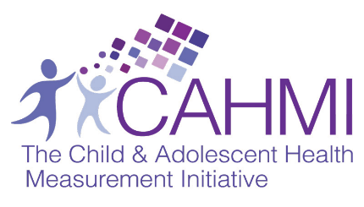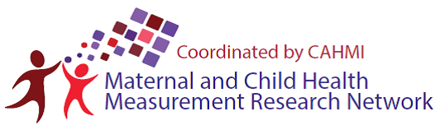

MCH-MRN Technical Working Groups

**What is an MCH-MRN Technical Working Group?**

A Technical Working Group (TWG) under the ***Maternal Child Health Measurement Research Network (MCH-MRN)*** is a group of 4-8 individuals who come together for the explicit purpose of **advancing the field of MCH measurement** by focusing on a priority topic. These individuals could include MCH researchers, advocates, practitioners, program specialists, policymakers, and more.

**What Defines “Success” for a TWG?**

“Success” for any MCH-MRN TWG includes accomplishing any of the following activities:

**What are some potential topics for the TWGs?**

Below are some potential TWGs you can get involved in. The priority areas were identified by the **strategic agenda** created by the 2013-2016 MCH-MRN.

**Other Topics of High Interest**

**Priority Areas**

* Positive health & flourishing
* Preventive health
* Family health
* Cross-cutting methods to optimize MCH data (exploring data linkages and local-area estimates)
* Perinatal health
* Transition to adulthood
* School readiness
* Health equity
* Age-specific health (middle childhood, adolescent health)
* Family engagement
* Oral health

**What are the benefits of participating in a MCH-MRN TWG?**

* **Get connected!** The MCH-MRN will connect you to a growing network of national and international experts who align with your skills, knowledge, and professional goals.
* **Get support and collaborate!** Tap into the MCH-MRN to advance your own work in MCH measurement.
* **You don’t have to reinvent or start from scratch!** You can use what has already been developed -- access and use resources developed by the Child and Adolescent Health Measurement Initiative (CAHMI), including the MCH-MRN Measurement Framework, MCH Measurement Development Process, MCH Measurement Strategic Agenda, [MCH-MRN measurement compendium](http://childhealthdata.org/browse/mchmeasurement/compendium) and other MCH measurement resources on the [CAHMI’s Data Resource Center](http://childhealthdata.org/browse/mchmeasurement/MRN-project).
* **Stay on the cutting edge!** Learn what others in the Network are doing, and learn how to maximize the CAHMI’s MCH measurement resources through regular webinars and national calls.
* **Help develop MCH measurement capacity in the field!** Support the next generation of MCH measurement experts on your team with your knowledge and skills.

**How Can I Get Involved?**

* Sign up for a TWG and learn more about the MCH-MRN: <http://childhealthdata.org/browse/mchmeasurement/MRN-project>
* Learn more about the priority MCH measurement areas identified by the MCH-MRN:

<http://childhealthdata.org/docs/default-source/MCH-MRN/mch-mrn-strategic-agenda-draft.docx?sfvrsn=2>

* Continue the conversation by emailing [info@cahmi.org](mailto:info@cahmi.org).

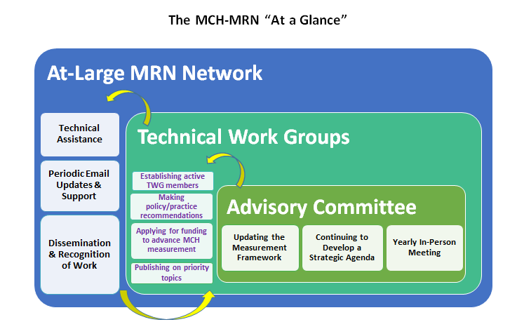

At the most basic level, 1-2 individuals will **identify a MCH measurement topic they wish to tackle, and agree to lead a TWG on that topic.** TWG team leaders then work with the CAHMI to identify and invite like-minded individuals with expertise and interest in the topic to join the TWG, using the Network list and their own contacts. The TWGs allow participants to engage at multiple levels, all of which have high value.

The TWG itself will decide **how, when, and how often to meet as well as what are the specific goals and outcomes** to be achieved. At a minimum, the TWGs will make recommendations to the MCH-MRN’s Strategic Agenda, apply for funding to support their work, and or publish on priority topics. The TWGs are provided with resources and support by the CAHMI to achieve their goals.

**How does the CAHMI support TWGs?**

CAHMI will support the TWGs by:

1. Assisting TWG leaders with **group start-up**
2. Providing a **TWG charter** that outlines TWG goals, functions, and the roles and responsibilities of TWG participants
3. Providing a **TWG Toolkit and resources** to help the TWGs get started and stay focused
4. Helping members use the **MCH measurement framework, MCH measurement compendium**, **and other CAHMI resources** through webinars and group instruction
5. Promoting the TWGs by **including TWGs in CAHMI MRN webinars and through CAHMI dissemination vehicles** (such as newsletters, social media, conference presentations)

**How are TWGs Developed and Organized?**

**The MCH-MRN is led by The Child and Adolescent Health Measurement Initiative, Johns Hopkins School of Public Health (**[**www.cahmi.org**](http://www.cahmi.org)**) and sponsored by the U.S. Health Resources and Services Administration (HRSA), Maternal and Child Health Bureau (MCHB) Grant #UA6MC30375.**